BACK PAIN INFORMATION SHEET

Back pain can be caused by a variety of reasons including overuse injury, sudden trauma, and/or underlying conditions such as arthritis.
Anatomy of the Spine & Hip

Trochanteric Bursitis - Your greater trochanter is typically located at the widest point of your hips. Bursitis is when the bursa, a "balloon" type structure which normally holds a small amount of fluid, becomes inflamed. This inflammation causes excess fluid to build-up within the bursa, leading to irritation in the surrounding areas.
Facet Joint – Facet joints are small joints at each segment of the spine that provide stability and help guide motion. The facet joints can become painful due to arthritis of the spine, a back injury, or mechanical stress to the spine.
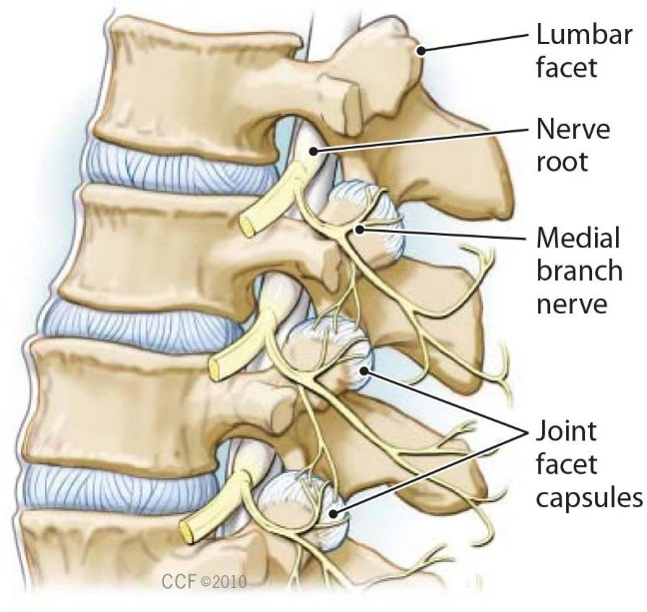
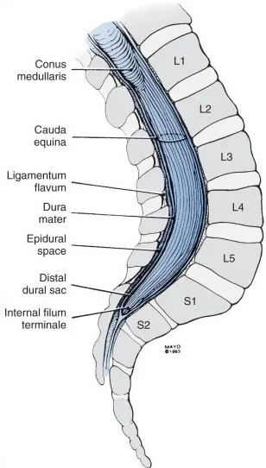

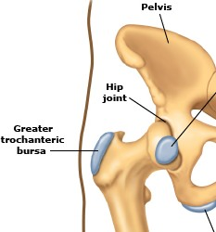
Medial Branch Nerves – Medial
site of injection in caudal epidural

branch nerves are small nerves that transmit the pain from the facet joints in the spine and carry pain signal from the facet joints to the brain.
Caudal Space - Space used to

administer a caudal epidural injection which involves placings a needle through an opening in the tailbone (sacral hiatus) to deliver medications into the caudal space. The lower portion of the spinal cord contains the nerves that extend out to the legs and feet and when these nerves become irritated or inflamed they can cause pain to radiate down the leg.
Erector Spinae Musclces – are a large group of muscles that run vertically on both sides of the spine, roughly one hand's width from the spinous processes. As a group, these muscles extend and stabilize the entire vertebral column and cranio-cervical region.

Other Important Treatments for Pain

Injections generally provide a temporary reduction in pain which is meant to help you start a rehabilitation program. Some of the items below may be important to your program. OHIP and private insurance will cover some of what you need, however, it may not cover everything, and you will have to invest both time and money in order to return to your maximum level of functioning.

- Pain Psychology: The mind has tremendous power over pain and we use it subconsciously all the time. Learning how to react and adapt to pain and its consequences can result in a range of emotional problems, such as depression and pain-related fear, which can lead to other negative effects on cognition such as poor concentration and memory, and failure to complete cognitive tasks.
  - We know that we are able to interpret pain in different ways depending on the circumstances, even though
the pain is the same. For example, a mother who has been looking forward to and preparing to have a child will probably experience less pain during birth than a teenager who became unexpectedly pregnant and is terrified or unprepared to have a baby. The pain they are going through is the same, however, they will experience it differently. Training your brain through Cognitive Behavioural Therapy (CBT) is an effective way to alleviate some of the negative emotional responses you may have to your pain.
  - CBT is a common treatment for chronic pain - this form of therapy is aimed at reducing the influencing
factors that create and maintain negative behaviours, beliefs, or thought patterns. CBT teaches patients how increased awareness of thoughts can reduce the severity of painful symptoms using a range of specific behavioural strategies to change interactions within their environment.
  - In these sessions, patients are educated on behavioural principles (e.g. conditioning, reinforcement, pain/
illness behaviours, attentional training), and how they interact with pain & disability; relaxation & controlled breathing techniques; and how to monitor situational factors that trigger pain/stress and what they actually experience emotionally, behaviourally, and physically when they have pain or stress.
  - Emotions: The pain centre in the brain is able to decide whether or not to send pain signals to the
amygdala, which is the emotion centre of the brain. The amygdala is responsible for enabling feelings such as fear, anxiety, and depression. When the brain is overwhelmed with pain signals, it sends signals to the amygdala to trigger these emotions when it otherwise shouldn't.
  - The Way Out by Alan Gordon describes more on how the brain and body interact and provides some
useful tools for reducing pain using pain reprocessing therapies.
For group or individual courses in Thornhill:
CBT Psychology
7626 Yonge St., Thornhill ON, L4J 1V9 Phone: 905-597-4404
Other resources: OPEN PATH http://oppc.mentalhealthexcellence.org/therapy-within-reach
OHIP Covered: http://www.selfhelp.on.ca/2015/08/cbt-therapists-ohip-covered/
Please also see the second last page for a list of Pain psychologists around the GTA

- Movement and Low Impact Exercise. Physical inactivity can lead to weakened muscles, worsening arthritis, increased pain and less mobility. Exercises that are gentle on your back. Walking is the simplest and most readily available exercise for low back pain. Gentle yoga, cycling, Tai Chi, qigong, swimming, aqua-therapy - whatever you like that doesn’t put too much pressure on the part that hurts -it is very important to keep moving. Aqua-therapy provides a program where you can get moving in a safe and comfortable environment. Exercise also helps to keep your bones and muscles strong which provides support for your joints.
- Active Physical Therapy. This is a very important part of any rehab program. Be sure to have an ACTIVE rehab physical therapy plan - not passive. Such a plan should involve condition-specific and patient-specific education on expectations, the recovery process, self-care strategies, and pain science. All delivered in combination with an active care rehabilitation / exercise program. All treatments should be aligned with the goal of improving a patient's active engagement and ability to engage in their own recovery. Bookings for a physiotherapist or chiropractor can be made through the front desk, or you can search for a clinic closer to you. If pain is in your leg -
"MacKenzie"exercises may help. Stuart McGill's "The Big Three" back exercises may help - these are available on YouTube. An initial assessment with a clinician will help identify the areas of weakness and individual plan of care using physical exercises and/or electronic devices. A physiotherapist will help with strengthening supportive muscles which will take the strain off the affected joint. Your physical therapist may recommend supportive equipment to help decrease pain and improve mobility.
- Acupuncture. This treatment can help increase blood flow to the effected joint and promote healing.
- Nutrition. Very important! It is not just about weight loss, which is important to less the load on the spine as well as decreased inflammation associated with certain types of body fat, but also avoiding foods which can cause inflammation in the body. There are also foods which fight inflammation!
It is very important to see a nutrition specialist to assess what you eat, and to make suggestions on what can be improved upon. It is not about going on a diet, but to make small changes that have a BIG impact! It is about keeping eating enjoyable and fun, but also healthy and sustainable. This is probably one of the most important parts of getting better.
If you are receiving steroid injections, it is very important to keep your bones healthy. Talk to your family doctor about whether you should be taking Vitamin D, calcium, or other bone strengthening medications. In addition, Vitamin K2 90mg (which usually comes with Vitamin D, and is different than Vitamin K) has been shown to help bone strength.
Foods that fight inflammation include: tomatoes, olive oil, green leafy vegetables, nuts (raw almonds, walnuts), fatty fish (salmon, mackeral, tuna, sardines), fruits (strawberries, blueberries, cherries, and oranges).
Foods that cause inﬂammation: reﬁned carbohydrates (white bread, pastries, bagels, mufﬁns), fried foods, pop, reﬁned sugars, red meat (burgers, steaks, unless grass fed), processed meat
(hot dogs, sausages), margarine, shortening and lard.

Incidentally, egg yolks, butter and health fat yogurt (Greek for example) is GOOD for you. Avoid low-fat foots as the taste is replaced by sugar which is BAD for you.
If you are finding that, despite everything you are doing, you are not able to lose wight, you may consider exploring Intermittent Fasting. You can find out more about this in a very readable book The Complete Guide to Fasting by Jason Fung MD.

- More information about foods that cause inflammation and foods that fight inflammation can be found at:
http://www.health.harvard.edu/staying-healthy/foods-that-ﬁght-inﬂammation Intermittent Fasting

Resource: The Complete Guide to Fasting by Jason Fung MD Please see back page for information on Registered Dietitians and Nutritionists in the GTA
- Support Groups. Especially helpful for fibromyalgia and chronic pain.
- Biofeedback. Especially helpful in headaches, jaw problems, fibromyalgia, brain injuries, and arthritis.
- Podcasts and Applications. "PainNoPain.com" is a podcast and website created by Dr's Wansbrough and
Perelman. "Calm" is an application which helps with meditation and relaxation. "Headspace" is a medication podcast which has a section dedicated to managing chronic pain.
- Books. Stuart McGill's book "Back Mechanic" coupled with his "Big Three" low back exercises are great resources which you can find on google. As well, ‘The Way Out: A Revolutionary Approach to Healing Chronic Pain’ by Alan Gordon, provides excellent insight into how pain affects the nervous system including the brain and how
you can harness the power of your brain to decrease the amount of pain we experience. Yes, the body and mind are intimately connected!

Medical treatments available to treat back pain include:

  - Surgery

  - Anti-inﬂammatory Drug Therapy

  - Steroid Injections

  - Prolotherapy
  - PRP (platelet rich plasma) Injections
  - Medications

  - Radio-Frequency Ablation (RFA)

Medications
Anti-inflammatories like ibuprofen (Advil) may be helpful, but may cause heartburn, stomach ulcers, high blood pressure, and kidney problems. these medications can be taken either orally or topically.
Acetaminophen is another option for chronic pain which is safe and relatively well tolerated at recommended dosages.
Pain related to nerve injury:
There are three types of medications which can help with pain related to damage nerves:

- Tricyclic Antidepressants (TCAs): Amirtriptyline (Elavil) and nortriptyline (Aventyl). These were found to help with pain, sleep, and depression. Although depression and pain often co-exist, they don't necessarily always come together. At doses lower than are used to treat depression, it was discovered that these medications also help with pain.
- Anti-Convulsant Drugs (ACDs): Pregabalin (Lyrica) and gabapentin (Neurontin): common side effects are dizziness and drowsiness which may go away as your body gets used to the medication.
- Serotonin Norepinephrine Reuptake Inhibitors (SNRIs): Duloxetine (Cymbalta), desvenlafaxine (Pristiq), and venlafaxine (Effexor). These medications also help to heal damaged nerves and decrease pain.

Your doctor will likely start these medications at a low dose and gradually increase it to allow your body to get used to the medication as some people have side effects such as dizziness and fatigue. The dose is increased until you have relief from pain, the side effects are worse than the benefit of the medication, or the drug's dose is at its maximum.

What are Cortisone / Steroid Injections?
Cortisone is a medicine that is injected into the body to help ease pain and swelling from arthritis, injury, or illness. Cortisone is sometimes called corticosteroids or steroids. These are not the same steroid used by body builders and/or athletes; your muscles will not get bigger. This medication mimics the effects of the hormone cortisol, which is produced naturally by our adrenal glands.

How much Cortisone / Steroid can I have?
It is recommended by the Canadian Osteoporosis Society not to receive more than 560mg of triamcinolone acetate per year, however this may vary depending on other health factors and need for pain relief.
What is PRP?
Platelet rich plasma (PRP) is blood plasma with concentrated platelets (the body's repairmen for damaged tissues). The concentrated platelets found in PRP contain growth factors that are vital to initiate and accelerate tissue repair and regeneration. Platelets initiate healing and repair, promote development of new blood vessels, and stimulate the healing process.
If you would like more information about this type of treatment, please discuss with your doctor MD, or take
one of our information pamphlets in the clinic.

What is Radiofrequency Ablation?
Radiofrequency Ablation (RFA) is a procedure using a special needle that heats nerves to reduce pain. An electrical current produced by a radiowave is used to heat up a small area of nerve tissue, essentially burning part of the nerve and thereby decreasing pain signals from that area.
RFA typically targets the medial branch nerves, which are located around the spinal facet joints (as seen on page 1).
RFA has been shown to demonstrate some short-term chronic pain reduction, but does not provide much benefit in the long run.

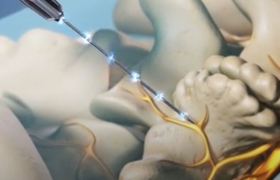
If you are a candidate for this procedure, you will be referred to a clinic who provides RFA by one of our physicians.

What is Prolotherapy?
Prolotherapy is a form of regenerative injection therapy.
It is a recognized orthopaedic procedure that stimulates the
body's natural healing processes to strengthen joints, tendons, and ligaments weakened by trauma or overuse injury. When a joint, ligament, and/or a tendon is stretched, torn, or fragmented, they become hypermobile and painful. Traditional approaches with surgery and anti-inflammatory drugs often fail to stabilize these areas. Prolotherapy, with its unique ability to directly address the cause of instability, awakens the body's healing cells to repair these weakened sites. If you would like more information regarding this treatment, please discuss with your doctor or take one of our information pamphlets in the clinic.

Information provided for you by Dr. Michael Wansbrough

865 York Mills Rd., Unit 20 North York, ON M3B 1Y6 (647) 477-7050
www.premierpain.ca

Chronic Pain Psychologist in the GTA

- Sara Trought (MA, RP, Member of OACCPP)
Languages Spoken: English Professional Psychotherapy Services 211 Danforth, 3rd Floor
Toronto, ON M4K (855) 873-4454
sara@therapytoronto.ca
Cost Per Session: $120-150

Rob Nolan (Psychologist, PhD, CPsych) Languages Spoken: English and French
1235 Bay Street 7th Floor Reception
Toronto, Ontario M5R (647) 933-5324
Cost per session: $200 - $220

Andrika Rook (RP (Q), BA, OPC, Dipl., Psych.) Languages Spoken: English and Ukrainian
14 Prince Arthur Avenue Suite 312
Toronto, Ontario M5R
(416) 962-8255
Cost per session: $120
Paul Kelly (Psychologist)
Languages Spoken: Farsi, Hebrew, Hindi, Polish, Portuguese, Punjabi, Russian, Serbian, Spanish, Urdu and French
The Mindfulness Clinic 700 Bay Street
Suite 2200
Toronto, Ontario M5G (855) 507-0092
Cost per session: $150-250
Group Therapy Available: Mindfulness- Based Cognitive Therapy (MBCT), Social Anxiety/Social Phobia Program, Mindful Self Compassion Group

Nilu Kulatunga (Registered Psychotherapist (Qualifying), CCC, MA, MSc)
Languages Spoken: English and Sinhalese Humber Bay Physio Inc.
2137 Lake Shore Boulevard West Etobicoke, Ontario M8V
(647) 492-3511
Cost per session: $120-130

Leila Abbaszadeh (Clinical Social Work/ Therapist, MSW, RSW, RP)
Languages Spoken: English and Farsi North York, Ontario M2K
(888) 539-9221
Cost per session: $150

Mariia Cohan (Registered Psychotherapist (Qualifying), M.Psych, RP (Q))
Languages Spoken: English and Russian L-Tower
8 The Esplanade Toronto, Ontario M5E (647) 360-2234
Cost per session: $80-120

Caroline Rosta (Registered Psychotherapist, M.Sc., M.A., OACCPP)
Languages Spoken: English and Spanish 1020 Eglinton Avenue West Toronto, Ontario M6C
Call Ms. Caroline Rosta (647) 560-0711
Cost per session: $130-180

Dr. Andrew Wong (Psychologist, PhD, CPsych) Languages Spoken: English and Cantonese
Andrew Wong Psychological Services Etobicoke, Ontario M9B
(877) 571-3037
Cost per session: $180

Mihaela Dirlea (Clinical Social Work/Therapist, MSW, RSW)
717 Bloor St W Toronto, Ontario M6G (647) 492-4318
Cost per session: $90-120
Group Therapy Available: Mindfulness- Based Cognitive Therapy (MBCT)

Holistic Nutritionists and Registered Dietitians in the GTA

Jill Hillhouse (BA, BPHE, CNP, RNT) http://jillhillhouse.com/personal-nutrition- consulting/
P3 health
145 Front St. East, Suite G2 Toronto, ON M5A 1E3
416-699-3636

Andrea Miller (MHSc, RD) http://www.amillerrd.ca

105 Consumers Dr., Unit 2 Whitby, ON L1N 1C4
905-233-2437
Cost: $100-$650

Lara Frendjian (RHN, CPA, CA) https://mycompletebalance.com/our-services/ nutritional-counselling/
Complete Balance
1100 Sheppared Ave East, Unit 309 Toronto, ON M2K 2W1
416-901-2873
Cost: $120/Initial Appt., $85/Follow-up Appt.

Renita Lam (BSc, MPH, RD) http://renitalam.com/services/
** Speaks English & Cantonese

North York @ 701 Sheppard Medical - 701 Sheppard Ave. East, Unit 218
Downtown Toronto @ Kyle Byron Nutrition - 98 Richmond St. East, Unit 450
Markham - 2600 John St., Unit 113 647-725-9765

Samantha Goren (HBSc, RD) http://foodhomeco.com/

Toronto Psychology and Wellness Group 3080 Yonge St., Suite 5090
Toronto, ON M5M 4N1 647-400-5579
info@foodhomeco.ca

Elizabeth Gullaher (RD, MHSc, BSc) http://www.thetherapycentre.ca/nutrition- counselling/
The Therapy Centre
2525 Old Bronte Rd., Suite 320 Oakville, ON L6M 4J2
289-291-0205

Maria Fisher (RD) http://www.mariafisher.ca/services.html
Aurora Medial Clinic
372 Hollandview Trail, Suite 302 Aurora, ON L4G 0A5
416-919-7130
Cost: $20-180

Anisha Gupta (RD) https://hellonutrition.ca/

Mississauga - 6033 Shawson Dr., Unit 8 Markham - 26 Starry Sky Ave.
647-408-6474
Cost: $130-500

